**TEAM ID :PNT2022TMID43906**

**Add CNN Layers**

import cv2

import numpy as np

from keras.datasets import mnist

from keras.layers import Dense, Flatten, MaxPooling2D, Dropout

from keras.layers.convolutional import Conv2D

from keras.models import Sequential

from tensorflow.keras.utils import to_categorical

import matplotlib.pyplot as plt

(X_train, y_train), (X_test, y_test) = mnist.load_data()

Downloading data from https://storage.googleapis.com/tensorflow/tf-keras-datasets/mnist.npz

11490434/11490434 [==============================] - 0s 0us/step

plt.imshow(X_train[0], cmap="gray")

plt.show()

print (y_train[0])

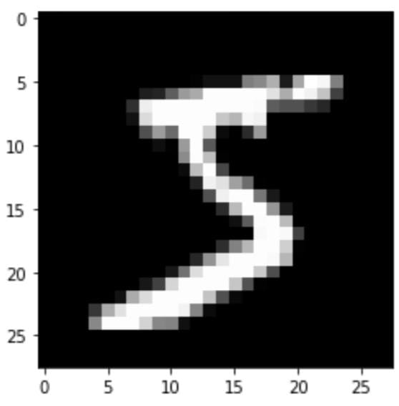

print ("Shape of X_train: {}".format(X_train.shape))

print ("Shape of y_train: {}".format(y_train.shape))

print ("Shape of X_test: {}".format(X_test.shape))

print ("Shape of y_test: {}".format(y_test.shape))

Shape of X_train: (60000, 28, 28)

Shape of y_train: (60000,)

Shape of X_test: (10000, 28, 28)

Shape of y_test: (10000,)

# Reshaping so as to convert images for our model

X_train = X_train.reshape(60000, 28, 28, 1)

X_test = X_test.reshape(10000, 28, 28, 1)

print ("Shape of X_train: {}".format(X_train.shape))

print ("Shape of y_train: {}".format(y_train.shape))

print ("Shape of X_test: {}".format(X_test.shape))

print ("Shape of y_test: {}".format(y_test.shape))

Shape of X_train: (60000, 28, 28, 1)

Shape of y_train: (60000,)

Shape of X_test: (10000, 28, 28, 1)

Shape of y_test: (10000,)

#one hot encoding

y_train = to_categorical(y_train)

y_test = to_categorical(y_test)

model = Sequential()

## Declare the layers

layer_1 = Conv2D(64, kernel_size=3, activation='relu', input_shape=(28, 28, 1))

layer_2 = MaxPooling2D(pool_size=2)

layer_3 = Conv2D(32, kernel_size=3, activation='relu')

layer_4 = MaxPooling2D(pool_size=2)

layer_5 = Dropout(0.5)

layer_6 = Flatten()

layer_7 = Dense(128, activation="relu")

layer_8 = Dropout(0.5)

layer_9 = Dense(10, activation='softmax')

## Add the layers to the model

model.add(layer_1)

model.add(layer_2)

model.add(layer_3)

model.add(layer_4)

model.add(layer_5)

model.add(layer_6)

model.add(layer_7)

model.add(layer_8)

model.add(layer_9)

**Compiling The Model**

model.compile(optimizer='adam', loss='categorical_crossentropy', metrics=['accuracy'])